E-Bill Express “EBE”-Online payment

Online payments can be accepted through the E-Bill Express “EBE” when the citation is past the appeal deadline. You will need the customers ID; this can be found on the Invoice or the citation under Customer #: and the zip code the citation went to.

- Go to the link, change tab to “Pay Now” enter customer number and zip code, then the green Pay Now button will take you to the invoices.
https://ww2.e-billexpress.com/ebpp/PORTSEAINV/
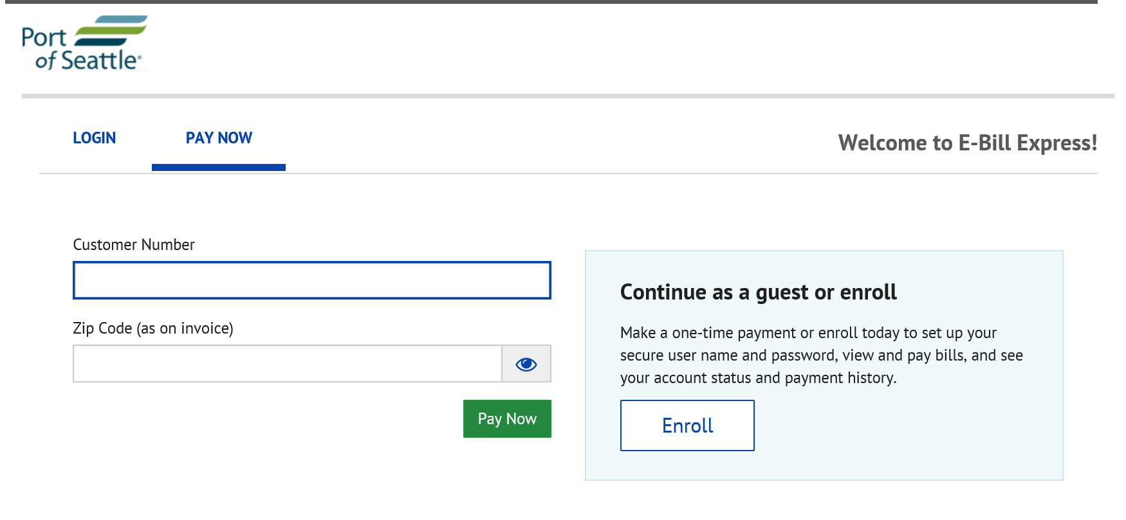
- Once there, click the top check box or invoice they are wishing to pay and then “Add A Payment Method”, enter check or card information.
- Continue to payment.
- Card will be charged a small fee, please print the operator a copy of their receipt.
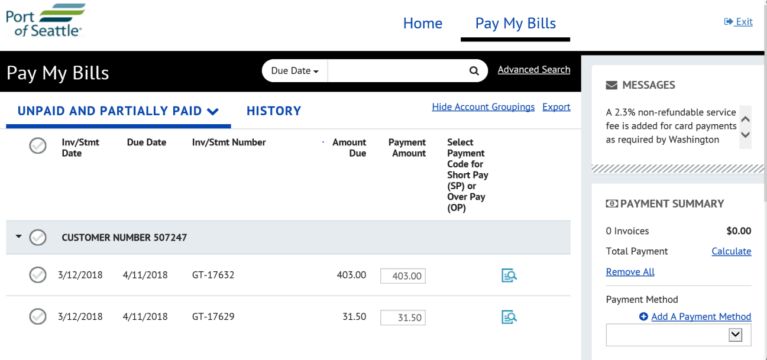

Things to Note:

- There is a 2.3% service fee for any card used. The amounted added on from the 2.3% goes directly to the VISA, MC. (RCW 36.29.190)

- Using a check is a way to avoid the service fee.

- Please email Kathy with what customer paid.

