REMATCH SOUTH ENTRY DIRECTIONS
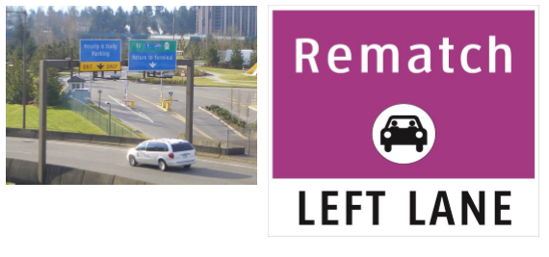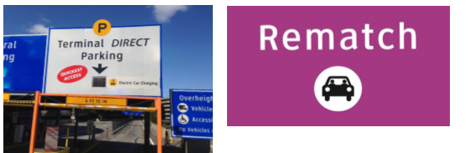
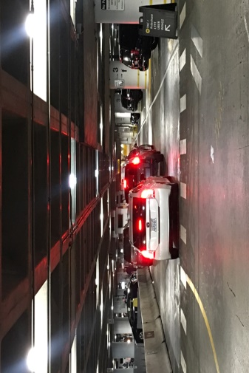
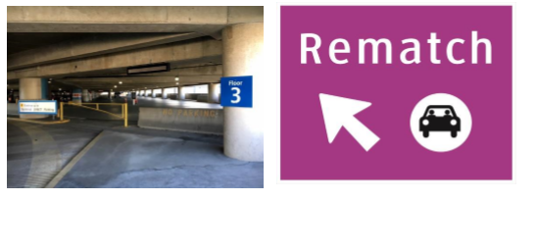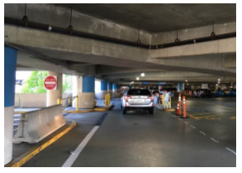

As you depart the Departure/Upper Drive merge to the furthest left lane and follow the overhead signs to “Parking.”

Follow the signs to “Terminal Direct Parking”

Once on the Helix exit onto the 3rd floor.

Continue to the pickup area.

Enter the pickup area through section G. Park your vehicle in any available stall in sections G, H, I, or J and then load your passenger(s).

