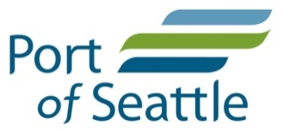
___________________________________________
Annual Industrial Stormwater Monitoring Report

Seattle-Tacoma International Airport

For the Period July 1, 2018 through June 30, 2019

September 30, 2019

Prepared by
Aviation Environmental Programs
Port of Seattle

Table of Contents
Table of Contents i
List of Tables ii
1.0 Introduction 1
2.0 Background 2
2.1 Seattle-Tacoma International Airport Drainage 2
2.2 STIA Storm Drainage Subbasins, Activities, and Outfall Descriptions 2
3.0 Sampling Results and Discussion 8
3.1 Monitoring of Industrial Stormwater Discharges 8
3.1.1 Sampling Objectives and Procedures 8
3.1.2 Field Quality Control Samples 9
3.1.3 Storm Events Sampled 9
3.1.4 Data Presentation Methods 10
3.1.5 Grab Sample Results and Discussion 11
3.1.6 Composite Sample Results and Discussion 15
3.2 Toxicity Monitoring 18
3.2.1 In Situ Toxicity Monitoring 18
3.2.2 Sublethal Deicing Monitoring……………………………………………….18
3.3 Priority Pollutant Monitoring 19
4.0 BMP Implementation 20
5.0 Summary and Conclusions 21
6.0 References 22

Appendix A: Tabular NPDES Sample Data Summaries
Appendix B: Other Sample Data

List of Tables
Table 1 STIA Subbasins and Associated Activity 4,5
Table 2 Constituents, Methods and Detection Limits 8

LIST OF FIGURES
Figure 1 NPDES Drainage Subbasins and Outfalls…………………………………….6
Figure 2 Rainfall Summary 9
Figure 3 pH Results 11
Figure 4 TPH Results 12
Figure 5 Turbidity Results 13
Figure 6 Copper Results 15
Figure 7 Zinc Results 16

Executive Summary
This Annual Industrial Stormwater Monitoring Report provides a summary of industrial monitoring results conducted pursuant to Part 2, Condition 2S1 of the National Pollutant Discharge Elimination System (NPDES) permit for the Port of Seattle’s (Port) Seattle-Tacoma International Airport (STIA) NPDES Permit WA0024651. Industrial stormwater discharges authorized under Part 2 of the permit include runoff associated with roads, runways, taxiways, airfield, rooftops, cargo operations, flight kitchens, and other areas associated with airport industrial activities, and excludes construction runoff and industrial wastewater discharges associated with ramp operations .

This report summarizes the results of stormwater sampling at outfalls listed in permit Condition 2S1 between July 1, 2018 and June 30, 2019 and satisfies the annual reporting requirement detailed in Part 2 Condition S2.G. Monitoring of construction activities, sanitary sewer discharges and the Industrial Wastewater System (IWS) are subject to other reporting requirements. Annual summaries of Part I IWS, Part I sanitary sewer monitoring results and Part 3 construction monitoring results are provided separately.

STIA met all required sampling collection and reporting requirements in the NPDES permit for the 2018-2019 data collection period with the exception of one missed outfall sample. Stormwater samples are collected from eleven (11) outfalls which discharge to five (5) different receiving waters; Lake Reba, Miller Creek, Walker Creek, Northwest Ponds, and Des Moines Creek. A total of forty-five (45) grab and fifty-two (52) composite stormwater samples from 16 storm events were collected in the past year with results reported on quarterly Discharge Monitoring Reports (DMRs).

There were nine (9) instances of permit limit exceedances (8) or non-compliance (1) associated with one missed sample and 239 individual constituent analyses.

In addition to routine NPDES monitoring required by Condition 2S1, the STIA conducted monitoring activities pursuant to other NPDES Part 2 permit conditions. in situ toxicity sampling (Condition 2S9) was conducted in the fall 2018 and spring 2019. Permit renewal priority pollutant and toxicity sampling was collected as required by Condition XXXX.

This page left intentionally blank.

Introduction
This Annual Report summarizes industrial stormwater monitoring results from the Seattle-Tacoma International Airport (STIA) as required by Part 2, Condition 2S1.G. of the Airport’s NPDES permit. The Permit authorizes discharges from airport industrial activities. Airport industrial activity areas include roads, runways, taxiways, airfield, rooftops, cargo operations, flight kitchens, and other areas associated with airport industrial activities. The purpose of this Annual Report is to present the monitoring results from discharges to the Airport’s stormwater drainage system (SDS) outfalls identified in Part 2 of the NPDES permit. This Annual Report does not address discharges to the Airport’s Industrial Wastewater System (IWS) or construction-related stormwater discharges.
The report covers samples collected in the 12-month period of July 2018 through June 2019. Outfall sampling results summarized in this report include data previously submitted to Ecology in the NPDES permit Part 2 Discharge Monitoring Reports (DMRs), plus additional stormwater sample data such as that from quality assurance sampling and samples that were analyzed for additional parameters not required by the Permit. These additional monitoring data are presented in Appendix B of this report. Toxicity monitoring and priority pollutant sampling as required by Part 2 of the NPDES permit are discussed but results will be contained in separate report submittals.
This report is organized into four sections following the introduction. Section 2 describes background conditions at the Airport including descriptions of each drainage subbasin and outfall sampling location. Section 3 presents all of the discharge monitoring report (DMR) related grab sample and composite sample analytical data collected during the reporting period and the rainfall totals for the period. Section 4 provides a summary of the effluent limit compliance and best management practices (BMP) implementation during the monitoring period. A summary and conclusion are provided in Section 5.

Background

Seattle-Tacoma International Airport Drainage
Located mid-way between the cities of Seattle and Tacoma, Washington, STIA was built in the 1940s and is owned and operated by the Port. According to the Port’s 2018 Airport Activity Report, STIA handled 438,391 aircraft operations, 432,314 metric tons of air cargo, and 49.8 million passengers. In 2018, the Federal Aviation Administration ranked STIA the eight busiest airport for passenger enplanements and twelfth busiest airport in the U.S. for aircraft operations.
Stormwater drainage at STIA is separated into two different collection systems, the Industrial Wastewater System (IWS) and the Storm Drainage System (SDS). The IWS receives stormwater runoff from the ramp and other areas involved with aircraft servicing and maintenance, providing treatment before discharge to Puget Sound through a separate outfall. Approximately 375 acres are diverted to the IWS.
The SDS drains over 1,200 acres. Half of this area is impervious and primarily associated with airport runways, taxiways, parking lots, roads and roof tops. The remainder is pervious which consists of landscaped or fallow open spaces and areas assocated with stormwater treatment best management practices (BMPs) such as runway filterstrips. About 25 percent of the area drained by the SDS flows to Miller Creek. This drainage area represents about 7 percent of Miller Creek’s watershed. Approximately 71 percent of the total SDS area drains to the Northwest Ponds and Des Moines Creek, which represents about 21 percent of the creek’s watershed.

STIA Storm Drainage Subbasins, Activities, and Outfall Descriptions
The Airport’s SDS is segregated into separate stormwater subbasins that each drain to individual outfall locations. The NPDES permit lists a total of thirteen (13) outfalls in two categories: Existing & New Outfalls and Subbasins, and Future Outfalls to be activated during future development. As of June 30, 2019, eleven (11) of the thirteen (13) outfalls are active and discharge stormwater related to industrial activity.
STIA stormwater subbasins are categorized according to their dominant activities: landside or airfield. These categories group subbasins together by similar land use and other characteristics. In general, passenger vehicle operations are absent from the airfield drainage subbasins while aircraft operations are absent from the landside subbasins. SDE4/S1 subbasin is an exception in that it includes both airfield and landside activities. Previous reports found that concentrations of total petroleum (TPH), total suspended solids (TSS) and other constituent concentrations were different for the landside and airfield categories (POS 1996a, 1997a.) Table 1, STIA Subbasin Characteristics, describes each active subbasin, receiving water, activities within each subbasin, stormwater management BMPs, and total pervious and impervious surface areas. The physical location of the outfalls listed in Table 1 are shown on Figure 1 along with additional receiving water monitoring locations used for sublethal toxicity and in situ toxicity testing.

Table 1. STIA Subbasins Characteristics
Outfall Name | Receiving Water | General Category | Industrial Activity | Non-Industrial Activity | Pervious Area^{b} (acres) | Impervious Area^{b} (acres) | Total Area^{b, c} (acres)
SDE4/S1 | Des Moines Creek (East Branch) | Landside | Limited portions of the airfield taxiways. | Public roads, vehicle parking areas, rooftops (terminal, hangar, cargo) and landscaped areas. | 41.6 | 138.1 | 179.6
SDD-06A | Des Moines Creek (East Branch) | Landside | Loading docks, vehicle maintenance, vehicle washing, equipment parking and maintenance. | Public roads, vehicle parking areas, rooftops (terminal, hangar, cargo) and landscaped areas. | 18.2 | 27.2 | 45.3
SDN1 | Miller Creek via Lake Reba | Landside | Flight service kitchen. | Public roads, building rooftops and vehicle parking. | 3.8 | 14.8 | 18.6
SDS3/5 | NW Ponds and Des Moines Creek West | Airfield | Ground surface deicing/anti-icing, aircraft taxi, takeoff and landings. | Perimeter road, open areas and building rooftops. | 206.3 | 250.6 | 456.8
SDS4 | NW Ponds and Des Moines Creek West | Airfield | Ground surface deicing/anti-icing, aircraft taxi, takeoff and landings. | Runway infield and open areas. | 40.4 | 25.9 | 66.3
SDS6/7 | NW Ponds and Des Moines Creek West | Airfield | Ground surface deicing/anti-icing, aircraft taxi, takeoff and landings. | Access roads, runway infield and open areas. | 68.9 | 48.2 | 117.1
SDN2/3/4ª | Miller Creek via Lake Reba | Airfield | Ground surface deicing/anti-icing, aircraft taxi, takeoff and landings. | Perimeter road, access road, taxiway infield and open areas. | 68.3 | 44.6 | 112.9
SDN3A | Miller Creek | Airfield | Ground surface deicing/anti-icing, aircraft taxi, takeoff and landings. | Perimeter road, runway infield and open areas. | 23.1 | 8.1 | 31.2
SDW1A | Miller Creek | Airfield | Ground surface deicing/anti-icing, aircraft taxi, takeoff and landings. | Perimeter road, runway infield and open areas. | 44.1 | 26.0 | 70.1
SDW1B | Miller Creek | Airfield | Ground surface deicing/anti-icing, aircraft taxi, takeoff and landings. | Perimeter road, runway infield and open areas. | 59.5 | 25.0 | 84.5
SDW2 | Walker Creek | Airfield | Ground surface deicing/anti-icing, aircraft taxi, takeoff and landings. | Perimeter road, runway infield and open areas. | 10.8 | 30.9 | 41.7
Note: |  |  |  | Total Area | 584.9 | 639.3 | 1224.1
a) The SDN2 runoff is pumped to IWS for all flows up to the 6 month /24-hour event. The SDN2 subbasin comprises approximately 46.5 acres, 36.6 of which are impervious. This area is included in acreages reported to the IWS.
b) Subbasin areas as described in the NPDES permit and updated annually in the STIAs Stormwater Pollution Prevention Plan.
c) Stormwater pond areas were not included in total acres. It is anticipated that ongoing changes resulting from planned construction will alter subbasin totals in the future.

Figure 1. Sampling Locations 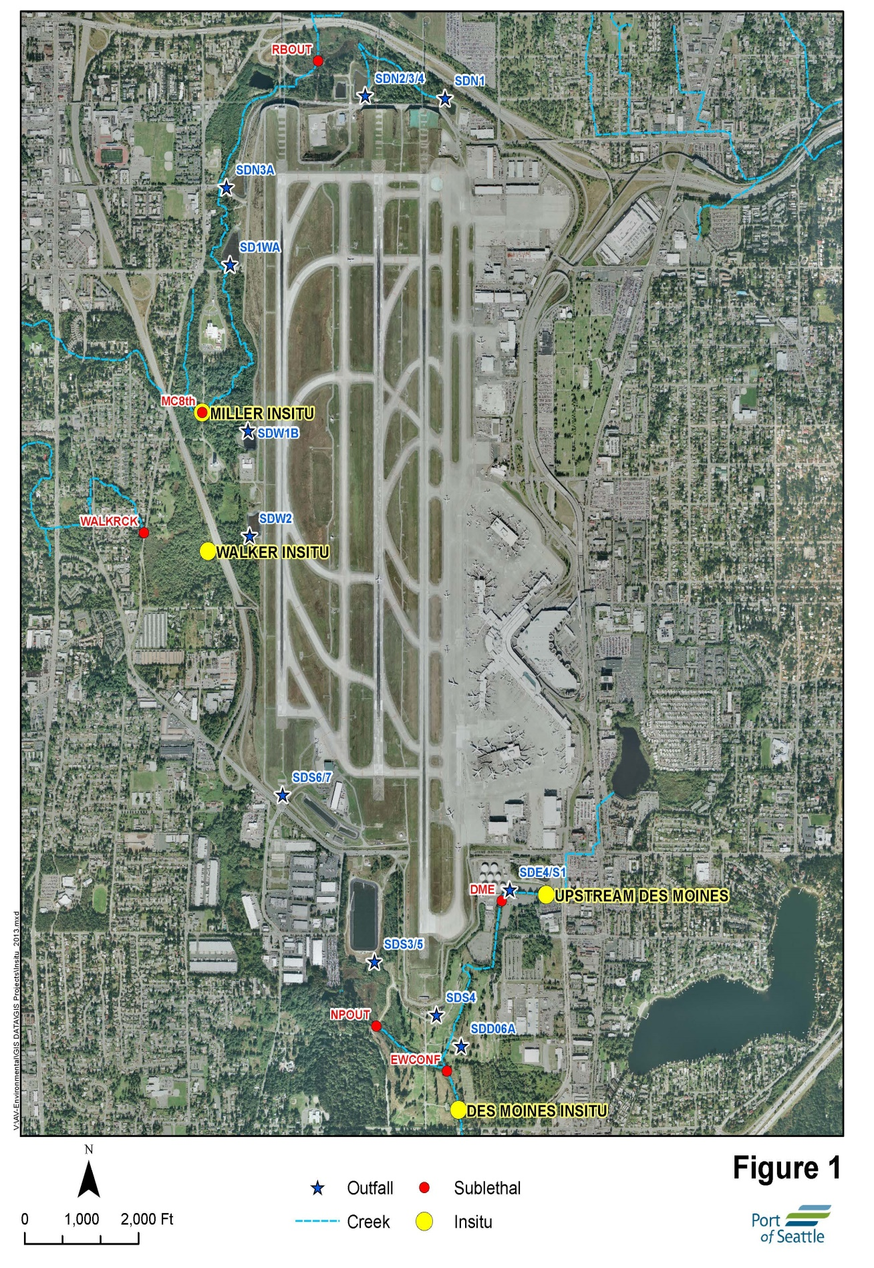

Sampling Results and Discussion
This section of the Annual Report summarizes the results of SDS outfall monitoring. All data summarized in this section has been reported to Ecology on quarterly DMRs and is included in Appendix A. Data generated from grab and composite samples are presented and discussed. These types of samples employ different protocols that represent different temporal periods of the particular stormwater discharge event and are therefore evaluated separately. Grab samples represent an instantaneous or short duration sampling period, while composites are collected over the storm event hydrograph to provide an event mean concentration (EMC).
In addition to the DMR data, this report summarizes other data collected at the outfalls listed in Part 2, 2S1 of the NPDES permit. These other data consist of field equipment blank samples, field duplicate samples, and other parameters collected during the monitoring period. These other data are presented in Appendix B. Section 3.2 of this report summarizes in situ toxicity testing at receiving water sites downstream of STIA outfalls

Monitoring of Industrial Stormwater Discharges

Sampling Objectives and Procedures
Sampling protocols and locations have been selected to provide data consistent with the requirements of the NPDES permit and the representativeness criteria set forth in the Quality Assurance Program Plan for Non-Construction Stormwater Runoff Monitoring (QAPP) (Taylor Associates, Inc. 2011 rev. 2013). The monitoring locations were selected to represent stormwater downstream of the last (BMP) within each subbasin.
The QAPP describes the criteria for sampling storm events and describes all relevant sampling, programming, and handling necessary to satisfy the monitoring requirements of the permit. Table 2 lists the current constituents measured or analyzed, methods used, and detection limits. The STIA reports results on DMRs from storms and samples that were considered representative according to criteria specified in the QAPP.
STIA uses telemetry-based automatic samplers to collect a grab sample followed by a flow-weighted composite sample during rainstorms of 0.10 inches or greater that are preceded by less than 0.10 inch of rainfall in the previous 24 hours. These rainfall and antecedent sampling conditions are specified in the NPDES permit, Part 2, 2S2.B. Each grab or composite sample is analyzed for the constituents listed in Table 2 based on sample type as specified in the NPDES permit.

Table 2. Constituents, Methods and Detection Limits
Constituent | Method | Detection limit (MDL) | Sample Type | Effluent Limits
pH | 150.1⁽¹⁾ | 0.01 S.U. | Grab | 6.5 – 8.5 S.U.³
Oil & Grease - TPH (by GC) | NWTPH-Dx⁽²⁾ | 0.75 mg/l | Grab | 15 mg/L – no sheen
Turbidity | 180.1⁽¹⁾ | 0.05 NTU | Grab | 25 NTUs
Total Recoverable Copper | 200.8⁽¹⁾ | 0.5 µg/l | flow-wt comp. | 25.6 to 59.2 µg/l
Total Recoverable Zinc | 200.8⁽¹⁾ | 4.0 µg/l | flow-wt comp. | 71.4 to 117 µg/l
1. Method refers to EPA-600/4-79-020 (U.S. EPA 1979).
2. Method reports both a motor oil fraction and diesel fraction. TPH-Dx is the sum of these two fractions.
3. Approved limits for pH at stations SDN3A, SDW1A, SDW1B, SDW2 are 6.3 to 9.0 S.U.

Field Quality Control Samples
STIA routinely collects field duplicate and equipment blank samples during NPDES sampling events in accordance with the QAPP. Appendix B summarizes these results. The results reflect on the efficacy of the STIA’s “clean” sampling methods developed for stormwater monitoring relative to metals (POS 1999).
Fifteen (15) Field Quality Control samples were collected in the 2018 – 2019 reporting period. There were no anomalies associated with samples collected during these same storm events.
Permit Effluent Limits
The current NPDES permit (2016) specifies effluent limits for turbidity, pH, oil and grease, total copper, and total zinc (see Table 2). The major changes from the previous permit effluent limits are the removal of lead analysis and an adjusted pH range for outfalls SDN3A, SDW1A, SDW1B, and SDW2.
Effluent limits for industrial stormwater became effective during the previous permit on December 31, 2007. The site-specific study and subsequent derivation of site-specific water quality based effluent limits for copper and zinc are described in the 2009 NPDES Permit fact sheet. A 25 NTU effluent limit for turbidity was added in the April 1, 2009 permit as a replacement for an earlier TSS benchmark.
The permit specifies effluent limits for ammonia and nitrates/nitrites, however monitoring for these parameters is only required if urea is applied as an anti-icing agent. Urea was not applied in this reporting year and has not been utilized at the Airport since 1996.

Storm Events Sampled
During the current permit’s annual reporting schedule, 31.62 inches of rain fell at STIA, 8.4 inches less than the historical (2002-2019) normal of 40.02 inches and 6.8 inches less than the past monitoring year (38.42 inches). Monthly rainfall totals were well below average in July, August, October, November, January, March, May, and June. December, February and April all had more monthly rainfall than normal. (Figure 2).

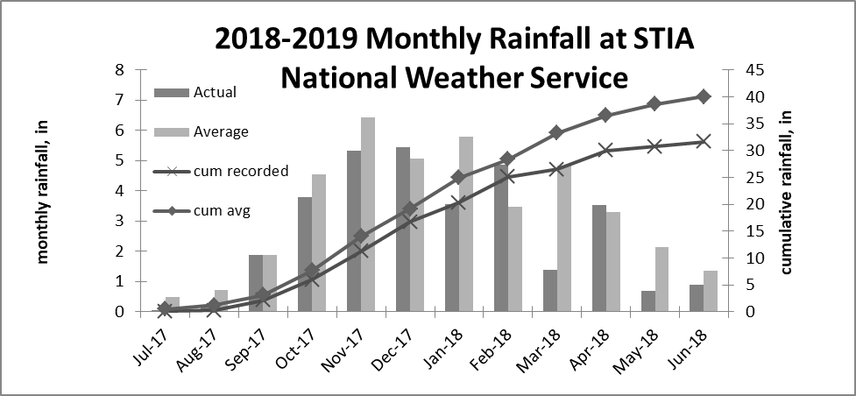
Figure 2. Rainfall Summary

During this reporting period, the STIA sampled sixteen (16) rainfall events with rainfall ranging from 0.13 to 3.4 inches. Dry weather preceding these events ranged from 14 hours (May 16, 2019) to 12.8 days (March 25, 2019). The tabular sample data in Appendix A includes storm event data such as rainfall depth, antecedent rainfall, and length of antecedent dry period.

Data Presentation Methods
Outfall sampling results for the reporting period are summarized graphically in box plots that illustrate the central tendency, spread, and skew of the stormwater data (Figures 3 through 7). For low-censored data (i.e. non-detected values), a value of one half the detection limit was assumed for any calculation purposes (i.e. median, percentiles, etc.).
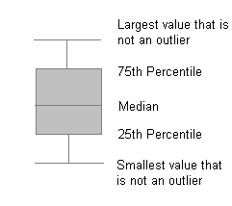
The data set may include outliers and extreme values that represent unusual conditions or anomalies. Outliers are displayed on the box plots as circles and extreme values are shown as asterisks.. A flat horizontal line indicates the analyte was not detected during the reporting period.
Appendix A tabulates and summarizes analytical results for each outfall for parameters required by the current permit, for the current annual reporting period July 1, 2018 through June 30, 2019. All data included in Appendix A has previously been provided to Ecology in quarterly DMRs and represents samples collected from those storms and sampling routines that met the criteria of the QAPP.

Grab Sample Results and Discussion
The following discussion includes results from 45 grab samples collected in the past year. Grab samples are analyzed for pH, TPH, and turbidity per current permit requirements, with tabular results and summary statistics contained in Appendix A.

pH
Figure 3 shows pH data for the current year. The median pH value from all outfalls was 7.2. Standard Units (S.U.) Sample results fell consistently within the effluent limit range of 6.5 to 8.5 (6.3-9.0 at SDN3A, SDW1A, SDW1B and SDW2) with the exception of five (5) samples. Three (3) samples for SDD06A had low pH reported. October 26, 2018, December 9, 2018 and March 12, 2019 measured 6.26, 6.05 and 6.29 respectively. The December 9, 2018 monitoring had two low pH measurments reported . The SDE4/S1 sample was 6.35 and the SDN1 sample was 6.48
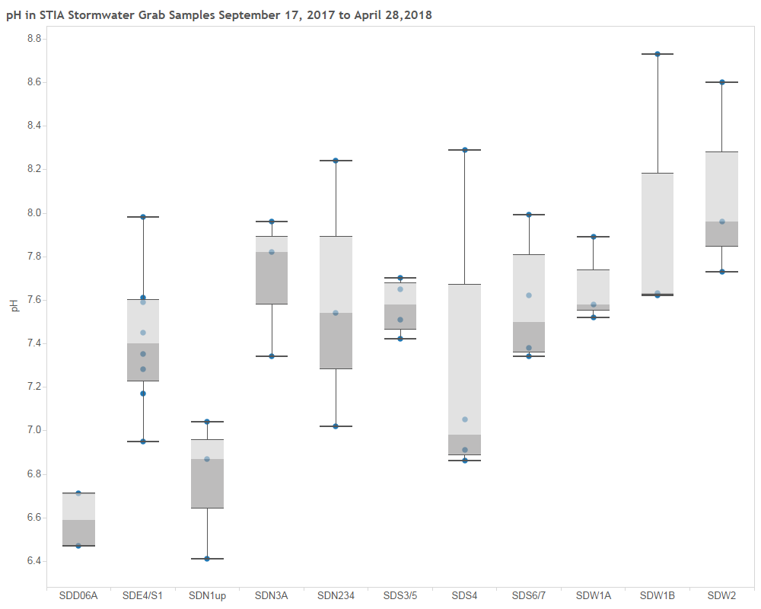
pH effluent limits: Stations SDE4/S1, SDD06A, SDN1, SDN2/3/4, SDS3/5, SDS6/7, SDS4 6.5 to 8.5.
Stations SDN3A, SDW1A, SDW1B, SDW2 6.3 to 9.0
Figure 3. pH Results

Total Petroleum Hydrocarbons (TPH)
Figure 4 shows TPH data for the current reporting year. TPH ranged from less than 0.15 mg/L to 0.90mg/L. The estimated median TPH concentration at all outfalls was 0.15 mg/L. However, the actual median TPH concentration may have been lower since TPH was only detected in 19 of the 45 samples. All sample results were well below the TPH effluent limit of 15 mg/L.
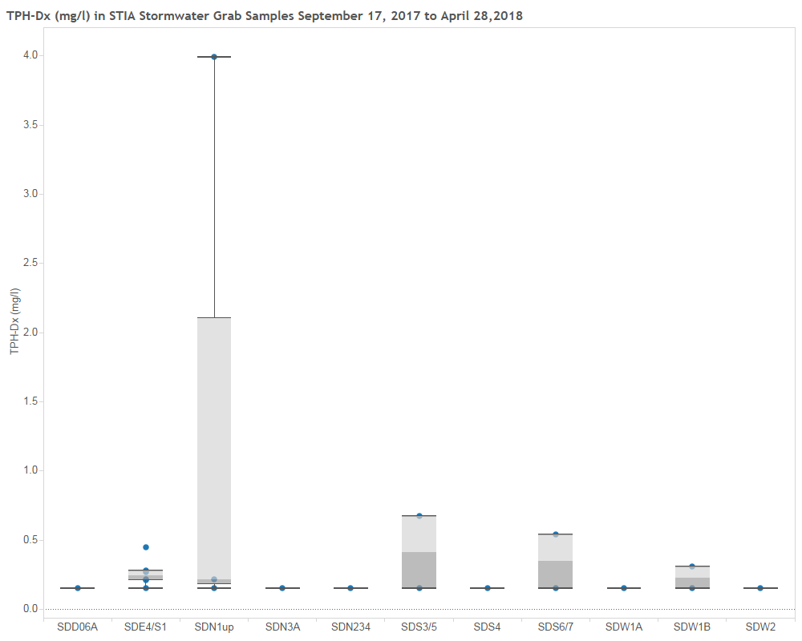
^{TPH Effluent Limit = 15 mg/L}
Figure 4. TPH Results

Turbidity
Turbidity results for the current year are shown in Figure 5. The median turbidity for all outfalls was 1.93 NTU with a range from 0.78 NTU to 7.36 NTU. There were no permit limit exceedances for turbidity at any outfalls during the monitoring period.
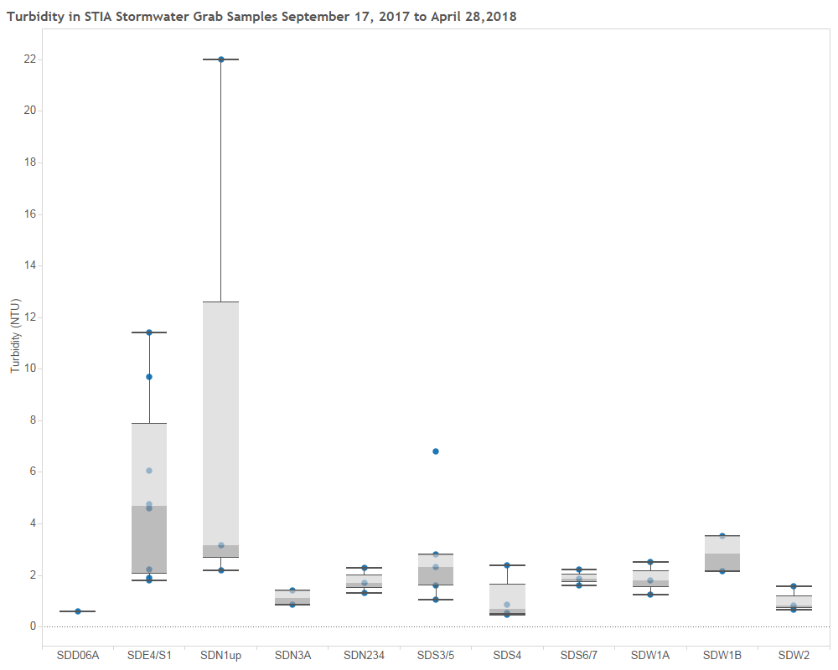
Turbidity Effluent Limit = 25 NTU
Figure 5. Turbidity Results

Composite Sample Results and Discussion
For the 2018-2019 sampling period, the STIA collected a total of 52 flow-weighted composite samples. Composite sample results are described separately from grab samples because grab samples represent an isolated segment of the storm event runoff. Composite sample results represent a flow-weighted average value over a longer time period. All composite sample data contained within this report and on the DMRs met the representativeness criteria of the STIA’s QAPP, which provides samples comparable with EPA methods (U.S. EPA 1992).

Copper
All data reported below are for total recoverable copper. The median copper concentration for all outfalls was 9.0 µg/L, with individual storm sample concentrations ranging from 2.0 µg/L to 45 µg/L (Figure 6). The permit effluent limit for copper at each outfall is variable based on a site-specific study and ranges from 26 µg/L to 59 µg/L depending on receiving water location. There were two permit limit exceedances for copper during the monitoring year. The September 14, 2018 sample at SDS3/5 measured 45.1 ug/L and the October 26, 2018 SDE4/S1 sample was 25.7 ug/L.

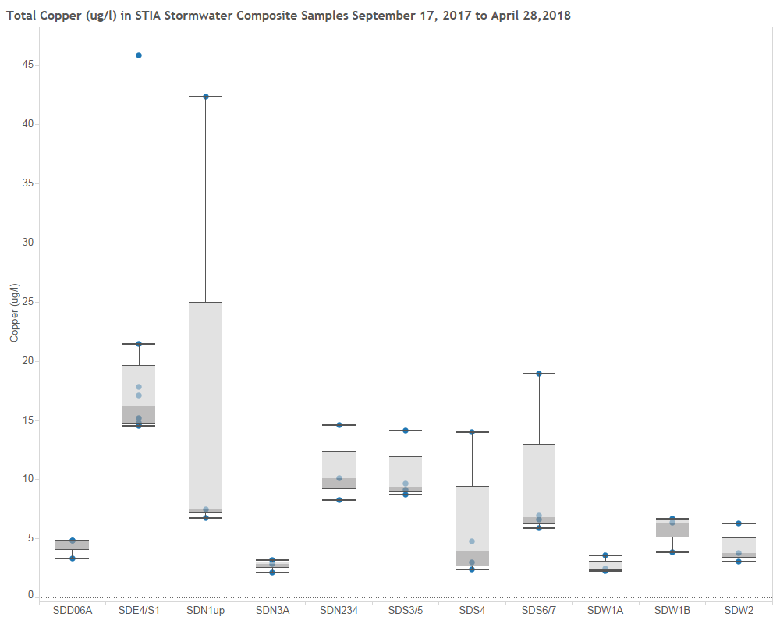
Effluent limits by outfall: 32.2 ug/l (SDS3/5, SDS4, SDS6/7), 28.5 ug/l (SDN1, SDN2/3/4), 25.6 ug/l (SDE4/S1, SDD06A), 59.2 ug/l (SDN3A, SDW1A, SDW1B), 47.9 ug/l (SDW2)
Figure 6. Copper Results

Zinc
All data reported are for total recoverable zinc. The median zinc concentration at all outfalls was 8 µg/L (Figure 7). Zinc concentrations ranged from 2 µg/L to 236 µg/L. There were two permit limit exceedances for zinc during the monitoring period. The September 14, 2018 SDS3/5 sample measured 236 ug/L and the May 17, 2019 SDE4/S1 sample measured 124 ug/L.

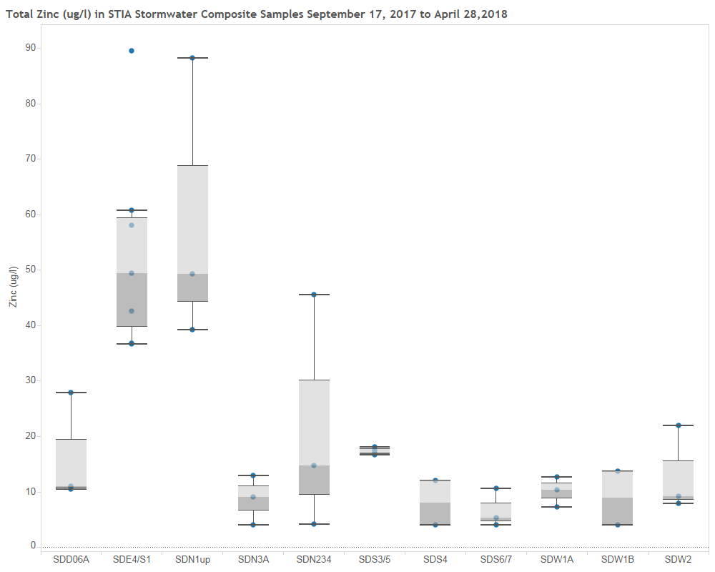
SDS4 effluent limit = 71.4 ug/l, all other outfalls 117 ug/l
Figure 7. Zinc Results

Toxicity Monitoring
The following sections discusses stormwater monitoring data related to the in situ monitoring program that was completed during fall 2018 and spring 2019 along with sublethal toxicity sampling completed during deicing events in February 2019.

In Situ Toxicity Monitoring
The in situ monitoring approach utilizes the early life stage (ELS) salmonid bioassay testing procedure using rainbow trout that can be applied in a laboratory or field (i.e., in situ) context. The test encompasses a number of developmental milestones (e.g., hatching, yolk-sac absorption, etc.), and provides a variety of biological endpoints, such as survival and growth, that can be used to assess water quality.
Results from the in situ bioassays and supporting analytical data are intended to provide an indication of attainment of receiving water quality standards and associated beneficial uses related to salmonid spawning and rearing. Initial Phase 1 testing conducted previously demonstrated that the RBT in situ ELS bioassay is an effective instream biological monitoring tool for assessing the potential effects of stormwater discharges on the receiving environment.
The sampling events conducted during this reporting period were completed under the Port’s Permit, WA0024651, Part 2. 2S9, and are required to be conducted biannually in the fall and spring, corresponding to the spawning regimes of local salmonid species. Sampling was performed using the revised Quality Assurance Program Plan: Seattle-Tacoma International Airport Receiving Water Sublethal Toxicity Testing (Port of Seattle 2016).
For a full discussion on results of the sampling, please refer to Rainbow Trout Early Life Stages In Situ Monitoring Testing, Fall 2018 and Spring 2019 Testing Events (Nautilus report in final preparation).

Sublethal Deicing Monitoring
The Port completed sublethal monitoring during several surface deicing events as required under Part X, XXXX which specifies collecting industrial stormwater samples during storm events concurrent with runway deicing. The Port sampled during February 5th, 6th and 12th, 2019 storm events and submitted samples to Nautilus Environmental for toxicity testing. There were no significant toxicity effects identified during these sampling events. For a full report on the results of this sampling please refer to NPDES Sublethal Toxicity Testing: Seattle-Tacoma International Airport, Nautilus Environmental, March 2019,(in final preparation for submittal).

Priority Pollutant Monitoring
The Port successfully completed required wet and dry season priority pollutant monitoring as required under Part 2, XXXXXX, which specifies collecting a wet and dry season sample during year three of the permit cycle. A validated summary of the priority pollutant sampling results will be presented during the submittal of permit renewal documentation.
Although there is not a final validated data package for the priority pollutant monitoring, results from the initial sampling have led to ongoing basin investigations (Winter 2018 sampling) for potential sources of Copper and Zinc. Based on findings from this investigation the Port will adjust BMP’s and tenant space operations as necessary to ensure continued compiance with permit conditions.

BMP Implementation
STIA designed and constructed stormwater peak runoff rate and flow control BMPS to retrofit the entire airport. In addition to flow control BMPs, treatment BMPs are implemented to achieve stormwater effluent limits. Redeveloped areas are assessed for BMP requirements and implemented as necessary to meet NPDES permit requirements During the design process, opportunities to implement LID technologies are explored.

During the 2018-2019 year, no new BMP’s were added for the industrial stormwater system. Maintenance of existing BMP’s continues with an emphasis being placed on sweeping and drainage system cleanouts.

Summary and Conclusions
During the reporting period from July 2018 to June 2019 the STIA fulfilled requirements for outfall monitoring under the current NPDES permit with the exception of one missed sample. The Port collected a total of 45 grab samples and 52 composite stormwater samples during 16 storm events. Outfalls were sampled quarterly when discharges occurred from rain events that met the minimum rainfall criteria of 0.1 inch. There were nine instances of permit limit exceedances (8) or non-compliance (1) associated with 97 samples (plus one missed sample) and 239 individual constituent analyses that were tested to meet the monitoring requirements of the NPDES permit. This high level of compliance is an indication that the stormwater BMPS and the overall stormwater management program are effective at mitigating impacts from Airport operations on the adjacent receiving waters.

References
Cardno TEC, Inc. 2012. Interim Report – Stormwater pH Study for Seattle-Tacoma International Airport In Accordance with Agreed Order 8755. June 2012.
CH2MHILL 2008. Comprehensive Receiving Water and Stormwater Runoff Study. Port of Seattle, April 2008.
Nautilus Environmental, LLC. 2008a. Derivation of Site-Specific Water Quality Objectives and Effluent Limits for Copper in Stormwater, June 23, 2008.
Nautilus Environmental, LLC. 2008b. Derivation of Site-Specific Water Quality Objectives and Preliminary Effluent Limits for Zinc in Stormwater, June 23, 2008.
Nautilus Environmental, LLC. 2010. Port of Seattle- Seattle-Tacoma International Airport In Situ Monitoring Plan, Phase I, Development and Demonstration, September 2010.
Nautilus Environmental, LLC. 2011b. Port of Seattle- Seattle-Tacoma International Airport Rainbow Trout Early Life Stages In Situ Bioassay Monitoring, Phase 1: Development and Demonstration – Fall 2010 and Spring 2011 Monitoring, September 14, 2011.
Nautilus Environmental Inc. 2014. NPDES Sublethal Toxicity Testing: Seattle-Tacoma International Airport, Fall Event (October) 2014, December 2, 2014.
Nautilus Environmental Inc. 2015. NPDES Sublethal Toxicity Testing: Seattle-Tacoma International Airport, Spring Event (April/May) 2015, June 5, 2015.
Nautilus Environmental Inc. 2015b. Port of Seattle, Seattle-Tacoma International Airport, Rainbow Trout Early Life Stages In Situ Monitoring Testing, Phase I: Development and Demonstration – Fall 2014 and Spring 2015 Testing Events, August 2015.
POS 1999. Adapting Clean Sampling Techniques for POS NPDES Stormwater and other Stormwater Monitoring Project Needs. Scott Tobiason, Port of Seattle, Aviation Environmental Programs. Draft 6/5/99.
POS 2012a. Letter addressed to Ed Abbasi, WA Department of Ecology, dated May 9, 2012. RE: Storm Drainage System In Situ Monitoring Plan Update – Continue Phase I Testing, Seattle Tacoma International Airport, NPDES Permit WA-002465-1, Part II Special Condition S9.
POS 2015. Letter addressed to Jerry Shurvey, WA Department of Ecology, dated May 28, 2015. RE: 2013-2014 Deicing/Anti-icing Fluids Usage Summary Report Seattle Tacoma International Airport NPDES Permit WA-002465-1, Part I Special Condition S2.E.
POS 2015. Letter addressed to Jerry Shervey, WA Department of Ecology, dated June 3, 2015. RE: Agreed Order No. 8755: Request for Notice of Compliance Seattle -Tacoma International Airport NPDES Permit WA-002465-1.

POS 2016. Quality Assurance Program Plan: Seattle-Tacoma International Airport Receiving Water Sublethal Toxicity Testing, Port of Seattle, February 2016

Snoeyink and Jenkins, 1980. Water Chemistry. John Wiley and Sons, Inc. 1980.
Taylor Associates, Inc. 2008. Comprehensive Receiving Water and Runoff Study – Effects of Airport Ground Surface Deicing Biochemical Oxygen Demand on Receiving Water Dissolved Oxygen. Port of Seattle, April 2008.
Taylor Associates, Inc. 2011. Quality Assurance Program Plan for Non-Construction Stormwater Runoff Monitoring, Conducted Under Part II of the National Pollutant Discharge Elimination System Waste Discharge Permit, Port of Seattle, Seattle Tacoma International Airport, October 2011.
U.S. EPA 1979. Methods for Chemical Analysis of Water and Wastes. EPA-600/4-79-20, U.S. Environmental Protection Agency, Cincinnati, OH.
U.S. EPA 1992. NPDES Storm Water Sampling Guidance Document. U.S. EPA Office of Water. EPA 833-B-92-001. July 1992.
U.S. EPA 1993a. Stormwater discharges potentially addressed by Phase II of the NPDES program. Draft report to Congress. October 1993.
WDOE 2009. National Pollutant Discharge Elimination System permit No. WA-002465-1, effective April 1, 2009 by Washington Department of Ecology, Olympia, WA.
WDOE 2016. National Pollutant Discharge Elimination System permit No. WA0024651, effective Janauary 1, 2016 by Washington Department of Ecology, Olympia, WA.
WDOE 2012. Agreed Order Docket No. 8755.

APPENDIX A
TABULAR NPDES SAMPLE DATA SUMMARIES and STATISTICS

This page left intentionally blank

APPENDIX B

OTHER SAMPLE DATA

This page left intentionally blank.

The length of the dry antecedent period (the “dryant” data field in Appendix A) is the time, in hours, to the previous measurable (0.01”) rainfall, which may or may not have actually produced runoff at a particular outfall.

