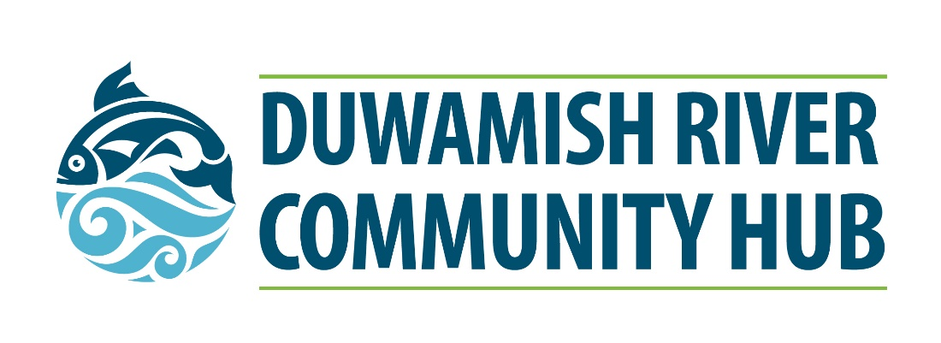
VENUE USE APPLICATION AND CONTRACT
The Duwamish River Community Hub is a place-based economic development resource center in the Duwamish Valley. This community asset is managed by the Port of Seattle in partnership with the Duwamish Valley Port Community Action Team (PCAT) to fulfil Resolution 3767, the Duwamish Valley Community Benefits Commitment. Please note that all proposed uses must align with Port-related career pathways in Section 1, refer to Section 4 for more details.

Located in the heart of the South Park business district, the Hub address is 8600 14th Avenue South, Seattle, WA 98108. It is accessible by King Country Metro bus lines (Route #s 131, 132, 60) and has its own gated parking lot.
INSTRUCTIONS FOR BOOKING THE HUB:
- At least 2 weeks prior to your event date, fill out the below form and email it to DRCH@portseattle.org
If you would like assistance filling out this form, please leave a voicemail at 206-787-5667 and a Port staff will call you to complete the form together. Note: YOUR EVENT IS NOT CONFIRMED UNTIL YOU RECEIVE WRITTEN APPROVAL FROM PORT STAFF AND PAYMENT IS RECEIVED.
- Schedule an in-person or virtual tour of the Hub with Port staff before your event.
- Sign contract and submit payment electronically. Port staff will assist you with this process.

- For more information about the Port’s Duwamish Valley Community Benefits Commitment, visit: www.portseattle.org/duwamishvalley

- For questions, please contact Port staff Peaches Thomas or Christina Billingsley at: drch@portseattle.org.

SECTION 1: EVENT USE DESCRIPTION

TABLE 1: User Information
Our proposed event connects to the following Port-related career pathways:

☐ Maritime and or Aviation Industry (ex: Fishing, Boating, Shipping, Cargo Handling, Cruise, Engineering, Airport Operations, Airport Dining and Retail, Aviation and Maritime Safety, Freight Movement and Transportation, Tourism and Travel)

☐ Economic Development (ex: Small Businesses and WMBEs)

☐ Workforce Development (ex: Skilled Trades and Construction)

☐ Environment and Sustainability (ex: Green Jobs, Water and Clean Air, Remediation and Clean Up, Energy and Climate Change, Habitat and Natural Resources)

Proposed Event Name: | Click or tap here to enter text.
Organization Name: | Click or tap here to enter text.
Mailing Address: | Click or tap here to enter text.
Organization Website or Social Media Handle: | Click or tap here to enter text.
Primary Contact Name/Title | Click or tap here to enter text.
Primary Contact Phone/Email | Click or tap here to enter text.
Venue Fee Payee Name (if different from above) | Click or tap here to enter text.
Venue Fee Payee Phone/Email | Click or tap here to enter text.

TABLE 2: Brief User Questionnaire

Please answer the below fill-in-the-blank questions to describe your event.
- This event is connected to Port-related career pathways because: | Click or tap here to enter text.
- The audiences we are serving include: | Click or tap here to enter text.
- This event contributes to economic recovery and equitable development because: | Click or tap here to enter text.
- The outcomes from this event will be: | Click or tap here to enter text.
- This event benefits the community because: | Click or tap here to enter text.
SECTION 2: VENUE RENTAL REQUEST

HUB SPACE MAP, FEES CHART & BUILDING HOURS

For a limited time only- 50% reduced rental fees until August 31, 2022!

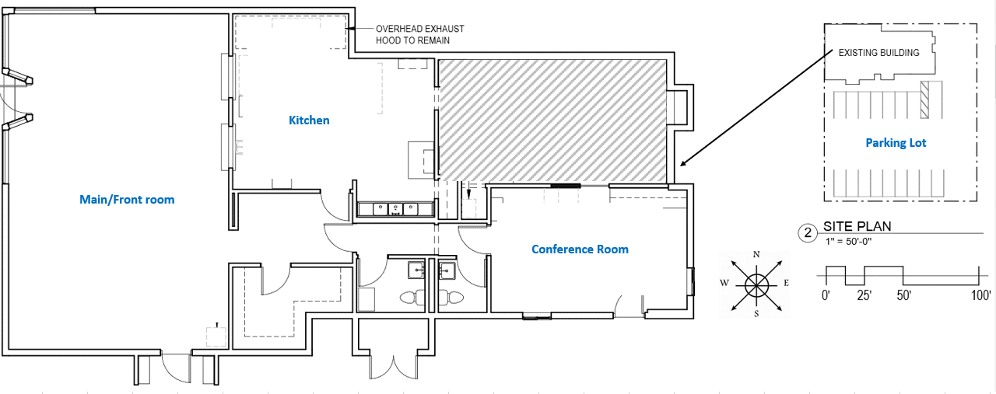
w

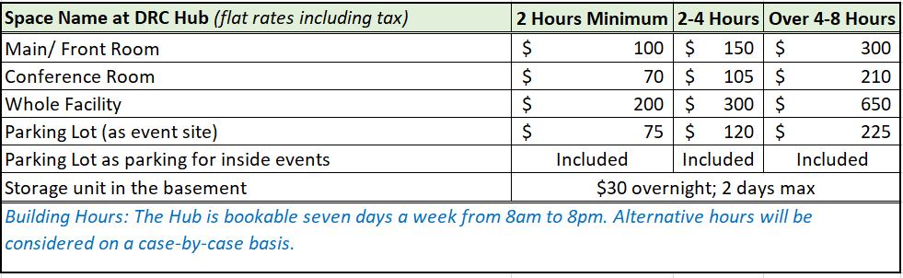
Building Amenities Available by Reservation:
- Front/Main Room – Capacity 50
- Conference Room (includes TV screen with USB connection) – Capacity 15
- Parking lot – Available for outdoor events (or included in room rental)
- Temporary basement storage for event-related needs, 2 days maximum (Please note $30 will be paid per day until your items are removed).
- BOOKABLE office equipment include:
  - 40 rolling chairs
  - 10 rolling 8 ft tables
  - 15 Dell laptops
  - 2 projectors
  - • Complimentary Wi-Fi
  - • Cafe area includes microwave, sink, and large refrigerator
  - • Two gender-neutral restrooms, including 1 diaper changing station
• ADA accessible

TABLE 3: Venue Rental Request

Please fill out the below table with details about your rental request.
Date(s) Preferred | Time(s) Preferred | Room(s) Requested | Estimated # Guests | Equipment Requested | Estimated Fees Due
Click or tap here to enter text. | Click or tap here to enter text. | Click or tap here to enter text. | Click or tap here to enter text. | Click or tap here to enter text. | Click or tap here to enter text.
Click or tap here to enter text. | Click or tap here to enter text. | Click or tap here to enter text. | Click or tap here to enter text. | Click or tap here to enter text. | Click or tap here to enter text.

Notes:
- For a limited time only, Hub use fees are 50% off until August 31, 2022.
- If you would like to request a waiver of venue fees, please explain the need in your application submittal. (You can write it in the body of your email submission or in a separate attachment).
- For multiple requests or event series, please indicate those details in Table 3 above.
SECTION 3: CONTRACT

The Port and the HUB user/organization have agreed to this Contract by their authorized representatives and this Contract serves as confirmation of Hub user/organization's upcoming event as outlined below.
TO BE COMPLETED BY PORT STAFF:
Day/Date | Period of Use | Space Location/Name | # Guests | Space Configuration | Space Rental
 |  |  |  | Total Space Rental: | $
 |  |  |  | Additional Charges: | $0.00
 |  |  |  | TOTAL: | $
- This application is an approved Trade, Business, or Community Development Expenditure

THIS DUWAMISH RIVER COMMUNITY HUB (DRCH) CONTRACT: Subject to the terms of this contract, the Port hereby grants to the Hub user/ organization the right to utilize the room(s) and space, as specified in the above table/section, located at 8600 14th Ave S, Seattle WA 98108 (“the Duwamish Hub” or “the Hub”) on the date and for the time identified above (the “Period of Use”).
PERIOD OF USE: Hub user/ organization may make use the specified space only for the Period of Use set forth in the section listed above. The Period of Use specifically includes set-up and clean-up time and is not subject to extension without the express written consent of the Port. Additional charges may be applied if the period of use extends beyond the times stated in this contract.
PAYMENT TERMS: The Port uses www.authorize.net to collect fees for use of the Hub. When use is approved by the Hub, an invoice will be created and sent by email to the party responsible for payment. No cash or check will be allowed. Payments must be received by the Port at least 48 hours prior to the start of the meeting or event to have access to the space specified in Contract. Please note the reservation or invoice number (DRCHMMDDYY**). Payments not received when due may result in access denial to event space.

CANCELLATION FEE: If cancellation is received later than 48 hours before use, the Hub will retain one hour’s fee. If Hub user/ organization is a “no-show”, then the entire fee will be retained.
No cancellation fee will be assessed if written notice is received within 48 hours before the start of the event. No cancellation fees will be assessed for cancellations related to COVID-19 or other reasons of force majeure.

SALES OF FOOD & BEVERAGES: No food or beverage sales will be allowed. User is welcome to provide food and beverage for attendees and is responsible for set-up and clean-up.
ROOM SETUP: For the Period of Use, the Port will provide a basic layout of furniture (for example: chairs, tables, laptops) that will be in standard layout. The User is responsible for additional set-up and clean-up and removal of any material added. In the event, that the Hub user/ organization makes disproportionate use of any service, or fails to return the HUB space in a neat and tidy condition, the Port reserves the right to charge the Hub user/ organization a reasonable amount for such excess or to remedy such condition.

PARKING AND PARKING LOT USE: When you are using the facility for a meeting or an event, the parking lot will be available for your attendees. If the parking lot is the site of your event, please refer the Use Rate Sheet for applicable fees.

USER RESPONSIBLE FOR SAFETY AND PROPERTY: The Hub user/ organization’s activities within, on or about the HUB will be at the Hub user/ organization’s sole risk. The Port will not be responsible for the safety of the Hub user/ organization, its employees, agents, licensees, or invitees, or for the condition or loss of any items of personal property brought to the HUB by any of them. In addition, the Hub user/ organization will be responsible to the Port for all damages or losses incurred by the Port or others arising from the Hub user/ organization’s use of the HUB, including rooms and parking lot, whether caused by the Hub user/ organization, its employees, agents, licensees or invitees.

COMPLIANCE WITH LAWS, RULES, AND REGULATIONS: At all times, the Hub user/ organization must comply fully with all applicable laws, rules, regulations, and codes, specifically including those promulgated by the Port for the general safety and convenience of its customers and the public. The Hub user/ organization must also refrain from any use of the HUB or surrounding areas that will unreasonably interfere with or interrupt the normal business operations of the Port or any other occupant of the HUB or any surrounding area.
INDEMNIFICATION: The Hub user/ organization agrees to indemnify, hold harmless and defend the Port, its employees, agents, and contractors against any and all liability, claims, losses, damages, penalties, charges, fines, injury, death, or damage to persons or property, expenses, and costs (including court costs and reasonable attorney’s fees), arising by reason of or in any way relating to the Hub user/ organization’s actions or those of its employees, agents, licensees, invitees or contractors.
INSURANCE REQUIREMENTS: The Port may require evidence of insurance coverage for certain meetings and events. The Port could require evidence of insurance coverage for social events taking place in the facility. An additional insured endorsement that includes the Port as an Additional Insured under the policy shall be provided to the Port.
APPLICABLE LAW; ATTORNEYS’ FEES: This contract shall be construed and enforced in accordance with the laws of the State of Washington. In the event the Port requires the services of an attorney in connection with enforcing the terms of this contract, the prevailing party shall be entitled to a reasonable sum for attorneys' fees, witness fees and other court costs and expenses, both at trial and on appeal.
CONTRACT; TERMINATION: This contract is a license. In the event, that Licensee fails to perform, keep or observe any of the terms, covenants or conditions of this contract, the Port may immediately terminate this contract by providing notice to the Hub user/ organization. In the event then notice is provided orally, it shall promptly be confirmed in writing. The Hub user/ organization shall have no recourse against the Port for any such termination. The Port may also terminate this contract in the unlikely event of an airport emergency or other circumstance beyond its reasonable control. In such event, the Port will provide Hub user/ organization as much advance notice as reasonably practicable, but the Port shall have no liability to Hub user/ organization for such cancellation. If an event is cancelled as a result of an emergency, the event may be rescheduled, without penalty, on a space-available basis, and any advance payments will be credited to the rescheduled date. If the Port and Hub user/ organization are unable to agree on a date to which the event may be rescheduled, the Port will refund any advance payments.
ACCEPTANCE Unless the Port otherwise notifies the Hub user/ organization at any time prior to the user/ organization’s execution of this contract, the reserved space will be held by the Port for the user/ organization 48 hours before the event. If the Port does not receive a signed contract by this date, the reserved space will be released. Upon the Port’s acceptance of a signed copy of this contract, the reserved space will be confirmed and this contract will be binding upon the Port and the User/ organization.

Approved and authorized by the User:
Printed Name | Click or tap here to enter text.
Signature | Click or tap here to enter text.
Title | Click or tap here to enter text.
Date | Click or tap here to enter text.

Approved and authorized by the Port:
Printed Name | Click or tap here to enter text.
Signature | Click or tap here to enter text.
Title | Click or tap here to enter text.
Date | Click or tap here to enter text.

SECTION 4: Guidelines for Hub Use
In accordance with Washington State Law and as outlined in Resolution 3767, the Duwamish Valley Community Benefits Commitment, all uses of the Hub will be in alignment of the Port’s economic development mission that promotes equitable access to Port-related careers for Duwamish Valley community members.

Events at the Hub must fall into one or more categories of activities that promote Port economic development and workforce development functions serving Port-related sectors including maritime, aviation, construction and Skilled Trades, and green jobs.

Hub users are encouraged to prioritize creating avenues for access for Black, Indigenous, Youth of Color, workers in transition (ex: formerly incarcerated, veterans), and workers with unique abilities or needs in their planning.

Specific examples of approved uses are listed below:

Maritime and Aviation (Ex: Fishing, Boating, Shipping, Cargo Handling, Cruise, Engineering, Airport Operations, Airport Dining and Retail, Aviation and Maritime Safety, Freight Movement and Transportation, Tourism and Travel)
- Educational activities raising awareness about maritime and aviation careers
- Career readiness workshops and professional development events such as resume/interview support

Economic Development (ex: Small Businesses and WMBEs)
- Educational events about contracting and employment opportunities at the Port
- Focused trainings for Women and Minority Owned Business Enterprises (WMBE) in Port-related sectors

Workforce Development (Ex: Skilled Trades and Construction)
- Career fairs by employers and industries who prioritize hiring Union workers
- Hands-on experiential learning activities and recruitment events promoting Port-related Labor Unions

Environment and Sustainability (Ex: Green Jobs, Water and Energy, Pollution Control, Remediation and Clean Up, Energy and Climate Change, Solid Waste Management, Habitat and Natural Resources)
- Duwamish River People’s Park and Shoreline Habitat events
- Environmental education related to Duwamish River, salmon habitat restoration, Port-related clean air and freight traffic issues
- Training and career awareness events about the green economy in Port-related sectors
Last updated 5/4/22

