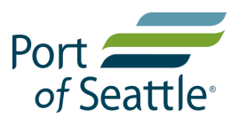
Energy Efficiency Program Incentive Application
Offer valid while funding is available.
Please submit this application to Aviation Utilities Group as soon as initial project scope is defined to ensure eligibility for incentives. All program information is available at:
https://www.portseattle.org/page/energy-efficiency-incentive-program
Eligibility Requirements
Your business must receive electric service from Seattle-Tacoma International Airport (STIA). In order to receive a rebate, your application must be accepted before purchasing equipment. Projects should not commence until the customer receives a written notice of acceptance from the Port. The Port reserves the right to reject any application that is incomplete or does not meet program criteria or standards.
Customer/Information
Tenant/Company Name: |  |  |  |  |  |  |  |  |  | Date:
Project Address: |  |  |  |  |  |  |  | Approx. Square Footage:
Contact Name: |  |  |  |  |  |  | Title:
Phone: |  |  |  |  | Email:
Project Information
Total Estimated Project Cost: |  |  |  |  | $
Estimated Start Date: |  |  |  |  |  |  |  |  | Estimated Completion Date:
Consultant/Contractor Company Name: |  |  |  |  |  |  |  |  |  | Contact Name:
Address:
Phone: |  |  |  |  |  |  | Email:
Brief Description of Project:

Brief project description continued…

